**OpenCV and Emgu Installtion Guide**

**Installing OpenCV**

1. Download 2.4.9
2. Extract to C drive (should look something like ‘C:\opencv249\...’)
3. Add path of bin folder (x86) to ‘path’ environment variable
   1. Path should read ‘C:\opencv249\opencv\build\x86\vc12\bin’
4. Add path of lib folder (x86) to ‘path’ environment variable
   1. Path should read ‘C:\opencv249\opencv\build\x86\vc12\lib’
5. Copy EyeToMouse1 from google drive to visual studio projects
6. Open .sln file, build and run

If Visual Studio has trouble loading any Opencv2 libraries try adding that folder (opencv2) to your ‘path’ environment variable.

NOTE: if you do not use the exact same paths as above, you will have to re-link all libraries to your opencv path.

This tutorial shows how to both add environment variables and link the C++ libraries for a C++ project. For C# you only need to add an environ variable.

*Note: You must restart Visual Studio in order for any environment variable changes to take effect. Also, the same goes for your command prompt.*

<https://www.youtube.com/watch?v=POpMQPM9YlY>

**Installing Emgu**

1. Download the x86 version of Emgu that supports OpenCV 2.4.9
2. Extract to C drive
3. Add path ‘…\bin\x86’ within the Emgu directory to your ‘path’ environment variable
4. Create a new C# Forms app
5. Go to ‘Project -> Add Reference’ and browse to and add the following dlls located in your ‘bin’ directory:

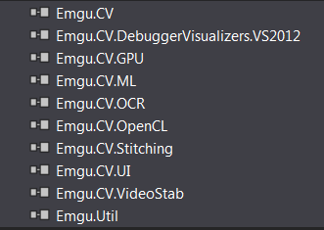

1. Next go to ‘Project -> Add existing Item’, browse to your ‘…\bin\x86’ directory and add every dll that begins with “opencv_”

If you get stuck or lost watch the tutorial at the following link.

<https://www.youtube.com/watch?v=vdjoutNR2DQ>

*Important! If you get the type initializer for 'Emgu.CV.CvInvoke' threw an exception error, check your environment variable path and that your VC++ libraries are up to date or visit the following link:* [http://www.emgu.com/wiki/index.php/Download_And_Installation#The_type_initializer_for_.27Emgu.CV.CvInvoke.27_threw_an_exception](http://www.emgu.com/wiki/index.php/Download_And_Installation%23The_type_initializer_for_.27Emgu.CV.CvInvoke.27_threw_an_exception)